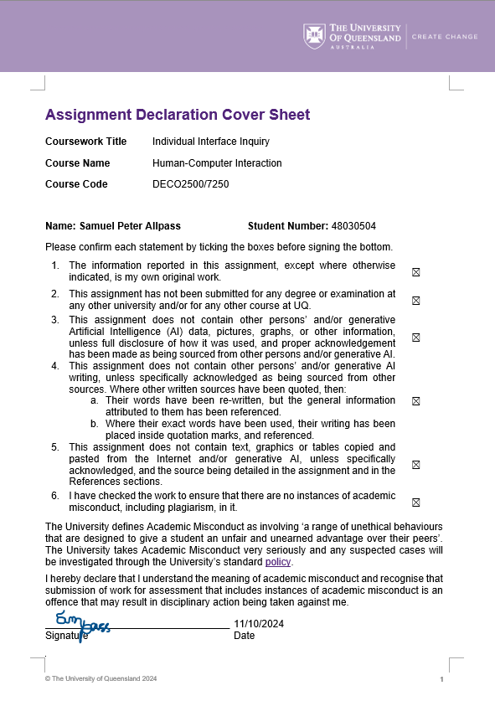

Australian Bureau of Meteorology website interface inquiry

By Samuel Allpass s4803050

Contents

1.0 Introduction 5

2.0 Expert Evaluation 6

2.1 Background 6

2.3 Process 6

2.4 Summary Table of Compliance with Nielsen’s heuristics 7

2.5 Summary Table of Violations and Recommendations 8

2.6 Description of Instances of Compliance 9

2.7 Description of Instances of Violations 11

3.0 User Based Evaluation 15

3.1 Background 15

3.2 Rational 16

3.3 Protocol 16

3.4 Collection of Data 17

3.5 Analysis of Data 19

4.0 Conclusion 20

References 21

Appendix 21

Appendix 1 21

Appendix 2 22

Appendix 3 22

Figures

Figure 1: BOM Queensland weather and warnings page within which the Expert evaluation was conducted 7

Figure 2: Depiction of 1st Nielsen heuristic compliance instance 9

Figure 3: Depiction of 2nd Nielsen heuristic compliance instance 9

Figure 4: Depiction of 6th Nielsen heuristic compliance instance 10

Figure 5: Depiction of 7th Nielsen heuristic compliance instance 10

Figure 6: Depiction of 9th Nielsen heuristic compliance instance 11

Figure 7: Depiction of 3rd Nielsen heuristic violation instance 11

Figure 8: Depiction of 4th Nielsen heuristic violation instance 12

Figure 9: Depiction of the 5th Nielsen heuristic violation instance 13

Figure 10: Depiction of the 8th Nielsen heuristic violation instance 13

Figure 11: Depiction of 10th Nielsen heuristic violation instance 14

Figure 12: Standardised SUS test questions (Bellio, 2024) 15

Figure 13: SUS score vs Percentile Rank (Sauro, 2018) 18

Figure 14: SUS score to adjective conversion table (Sauro, 2018) 18

Tables

Table 1: Summary table of compliance with Nielsen's heuristics 7

Table 2: Summary table of violation with Nielsen's heuristics 8

Table 3: Conversion of Raw results to SUS score 17

# 1.0 Introduction

In the same way that customer service promotes shoppers coming back to stores, a simple, friendly and intuitive user interface promotes user retention and repeated visits to a website. It is through expert and user evaluation techniques that the usability of a system can be analysed, quantified and further compared against existing user interfaces to evaluate its success at providing a service whilst adhering to current user mental models. As such, it was detailed that an interface inquiry would be conducted on the Australian Bureau of Meteorology website.

The Australian Bureau of Meteorology is the national standard weather, climate and water agency, assisting everyday Australians navigate “the harsh realities of their natural environment” (BOM, n.d.). Given the necessity and criticality of information that the BOM interface provides, it is essential that relevant information should be easily accessible for both novice and experienced users. The purpose of such an investigation is to provide quantitative and qualitative feedback to BOM UI developers surrounding the systems strengths, weaknesses and severity and potential solutions of given weaknesses.

It was concluded that the most effective interface inquiry would feature both an expert evaluation in addition to a user evaluation. An expert evaluation would first detail a large variety of UI strengths and weaknesses, and further the user evaluation would highlight the relative importance of said issues from a user perspective.

Expert evaluations incur the the formative analysis “performed by designers and usability experts” in order to effectively outline the extent of a systems usability, functionality and effect on potential users (Robert Pastel, 2017). Given the vast functionality and diverse userbase of the BOM, it was justified that Nielsen’s 10 usability heuristics would be consulted as the method provides analysis of varying user-oriented usability protocols. Although extremely efficient in identifying a multitude of system heuristic compliances and violations, the expert evaluation can be limited in assessing the relative importance of issues. As such it was decided to employ an additional series of user-based evaluation methods to highlight what UI strengths and weaknesses a sample of users found most prevalent.

Initially the system usability scale (SUS) was chosen to evaluate the Bureau of Meteorology website. The purpose of the SUS test was to quantitatively understand how and why people adapted to the user interface. Additionally, the standardised SUS questions highlight the complexity of the system whilst the score itself is effective in comparing the UI against other systems within a database. However, evaluation of the SUS test found two major drawbacks. The test provides no detail into how to make the interface more usable whilst also neglecting how varying mental models may interact differently. As such, it was determined to also conduct a think aloud test in order to identify where users were most likely to struggle when navigating within the UI. Although think aloud tests provide limited information into the relative importance of identified problems, the process of identifying them alone will be useful for future development regardless.

# 2.0 Expert Evaluation

## 2.1 Background

As defined by the esteemed Nielsen Norman group, UX expert reviews are defined as the “analysis of a design by a UX expert with the goal of identifying usability problems and strengths,” (Harley, 2018). In order to appropriately access usability problems and strengths within the Bureau of Meteorology website, as previously justified, Nielsen’s 10 heuristics would be employed. The purpose of the expert investigation was to provide a framework of compliances and violations through which a potential BOM UX developer could implement extensions and solutions. Each compliance and violation were to be equipped with a screenshot of the specific example as to identify to potential developers where the UI succeeds or fails. Additionally, each instance of violation would also include descriptors for potential issues with a respective severity, which as Jakob Nielsen explains, allow the appropriate allocation of resources among the issues (Nielsen, 1994). It was recognised that a user-based evaluation could further indicate the relative importance of such violations from a user perspective.

## 2.3 Process

In order to successfully complete an expert evaluation, a clear and thorough investigation of the BOM interface and the majority of its functionality must be conducted. It was concluded that the evaluation would first consist of a general overview, systematically investigating each functionality of the interface. This was achieved by primarily focusing on all offered features within the Queensland “weather and warnings” page as outlined in figure 1.

Figure 1: BOM Queensland weather and warnings page within which the Expert evaluation was conducted

Throughout this brief overview, notable compliances or violations of the 10 heuristics were recorded. Succeeding this initial investigation, a detailed analysis of the noted instance compliances and violations was to be conducted in order to either encourage similar design decisions in future or provide relevant feedback on existing systems. It was identified that the construction of compliance and violation summary tables with appropriate instance records and feedback would be the most effective method of translating the findings into developer friendly feedback.

## 2.4 Summary Table of Compliance with Nielsen’s heuristics

Table 1: Summary table of compliance with Nielsen's heuristics

|  |  |  |  |
| --- | --- | --- | --- |
| **#** | **Instance of Compliance** | **Heuristic/Rule/Principle** | **Evidence** |
| **1** | Titling text boxes outlining the purpose of the particular page | #1 Heuristic: Visibility of system status | Figure 2: Depiction of 1st Nielsen heuristic compliance instance |
| **2** | Map of Australia with selectable state information. | #2 Heuristic: Match between system and the real world | Figure 3: Depiction of 2nd Nielsen heuristic compliance instance |
| **3** | Consistent identification of relevant state (Queensland) | #6 Heuristic: Recognition over recall | Figure 4: Depiction of 6th Nielsen heuristic compliance instance |
| **4** | MetEye forecast analyser for expert users | #7 Heuristic: Flexibility and efficiency of use | Figure 5: Depiction of 7th Nielsen heuristic compliance instance |
| **5** | Appropriate error messages for inactive satellite images | #9 Heuristic: Help users recognise, diagnose and recover from errors | Figure 6: Depiction of 9th Nielsen heuristic compliance instance |

## 2.5 Summary Table of Violations and Recommendations

Table 2: Summary table of violation with Nielsen's heuristics

|  |  |  |  |  |  |
| --- | --- | --- | --- | --- | --- |
| **#** | **Instance of Violation** | **Heuristic Rule/principle** | **Evidence** | **Severity Rating** | **Recommendation** |
| **1** | No undo feature when entering the national radar loop | #3 Heuristic: User control and freedom | Figure 7: Depiction of 3rd Nielsen heuristic violation instance | 2 | Implementation of BOM UI standardised back button similar to google |
| **2** | Seemingly identical buttons for state selection | #4 Heuristic: Consistency and standards | Figure 8: Depiction of 4th Nielsen heuristic violation instance | 2 | Removal of “warnings current” state selection menu |
| **3** | Email sign up fails to recognise fake email address | #5 Heuristic: Error prevention | Figure 9: Depiction of the 5th Nielsen heuristic violation instance | 3 | Implementation of email validity checker prior to subscription submission |
| **4** | Congested and unappealing UI buttons | #8 Heuristic: Aesthetic and minimalist design | Figure 10:  Depiction of the 8th Nielsen heuristic violation instance | 2 | Smaller submenus along with implementation of illustrations |
| **5** | Failure to provide easy access to help documentation from the relevant page | #9 Heuristic: Help and documentation | Figure 11:  Depiction of the 9th Nielsen heuristic violation instance | 1 | Implementation of hyperlinks to help documentation about the page/functionality of reference. |

## 2.6 Description of Instances of Compliance

Figure 2: Depiction of 1st Nielsen heuristic compliance instance

The heuristics first describe the visibility of system status, that is to say that user-induced changes to the system should produce reasonable feedback within some short period. The BOM UI consistently provides the user with an information text box outlining what the particular page is dedicated to. This is clearly demonstrated in figure 4 with the system outlining that the “page provides a summary of valid weather warnings issued in this state”.

Figure 3: Depiction of 2nd Nielsen heuristic compliance instance

Nielsen’s second heuristic exclaims that interfaces should strive for a match between the system and the real world, such that the communication between the user and the system is coherent and seamless. Accordingly, the BOM interface expertly draws correlation from the real world using the familiar map of Australia with selectable buttons as depicted in figure 5, directly interacting with typical user mental models.

Figure 4: Depiction of 6th Nielsen heuristic compliance instance

Neilsen’s theory promotes recognition over recall such as to minimise user cognitive load by consistently placing reminders of relevant data. This was observed throughout the investigation, an instance of which outlined in figure 5. The figure depicts a webpage accessed by the Queensland state menu on the home page. Further, even in the marine and ocean page, users are met with the country map with Queensland highlighted, assisting in recognising the current position in the interface without having to use active recall.

Figure 5: Depiction of 7th Nielsen heuristic compliance instance

Nielsen’s seventh heuristic outlines the optimisation of a UIs flexibility and efficiency of use, supporting the use of shortcuts hidden from novice users, but still speeding up the expert interaction experience. As is provided in figure 5, the BOM interface provides experienced users to tailor fit forecasts with additional layers like wind direction, rainfall intensity, and ocean data. This personalised shortcut provides a clear compliance with Nielsen’s seventh heuristic.

Figure 6: Depiction of 9th Nielsen heuristic compliance instance

Nielsen’s second last heuristic documents that systems should help users recognise, diagnose and recover from errors. This was demonstrated in the figure 6 instance when it was attempted to view a currently unavailable radar service. As the heuristic recommended, the BOM UI successfully provides the user with an appropriate error message, populated with the error reason, duration and estimated restoration of service, precisely complying with the requirements of the heuristic.

## 2.7 Description of Instances of Violations

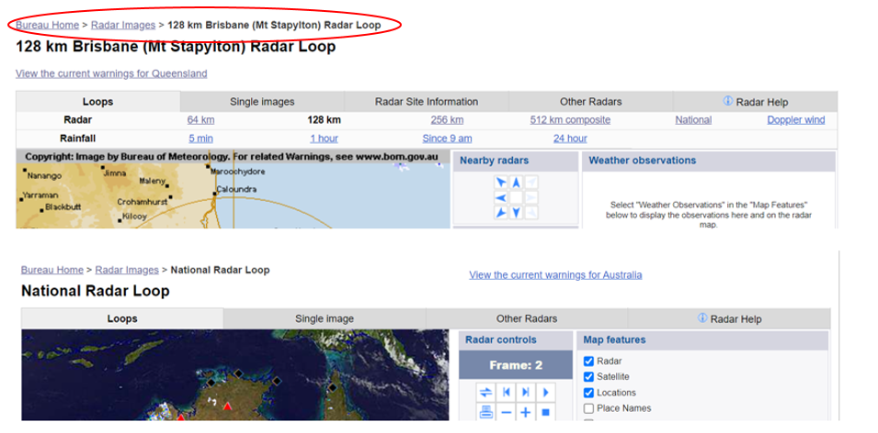

Figure 7: Depiction of 3rd Nielsen heuristic violation instance

The third heuristics endorsed user control and freedom by suggesting the system feature mistake fixing “emergency exit” buttons to unwind actions. Despite this, the BOM interface clearly stands in opposition to this typical user mental model. As outlined in figure 7, when navigating to the national radar loop from the Brisbane radar loop, no clear back button is identified other than the radar images tab in the top left directory. However, the back button does not return to the previous state, but rather to the same directory the preceeds the Brisbane radar. As such, the instance clearly violates the third heuristic with a severity rating of 2. Furthermore, it was proposed that a standardised undo/redo button pair would prove a solution whilst also adhering to the currently accepted simplistic back and forward button system users expect.

Figure 8: Depiction of 4th Nielsen heuristic violation instance

The fourth heuristic outlines the importance of consistency and standard throughout the user interface. Within the expert analysis, it was noted that the state selection menu indicated in the top right was vital in navigating back to states from many pages, however, when placed in the context of the home screen, the state selections are repeated three times. This raised concerns surrounding the functionality of each state set, evidently violating the fourth heuristic with a severity rating of 2. It was discussed that to ensure consistency throughout the user interface, the top right state menu should remain, however, the “warnings current” selection should be placed within its own dropdown or page to avoid user confusion.

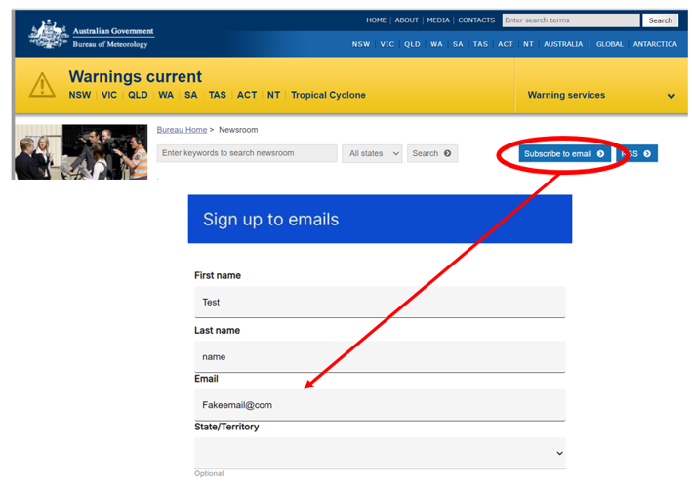

Figure 9: Depiction of the 5th Nielsen heuristic violation instance

Although an interface must correctly handle errors, describing them to the user appropriately, Nielsen’s heuristics exclaims that error prevention itself is key. Within the instance outlined in figure 9, the BOM UI vividly violates this heuristic, failing to identify the use of a fake password when subscribing to the newsletter. This violation induces a severity rating of 3 potentially leading to extreme degradation of UX and computer process wastage. Simply, it was suggested that the BOM UI employ an email validity prior to the subscription submission.

Figure 10: Depiction of the 8th Nielsen heuristic violation instance

Nielsens eight heuristic identifies that an aesthetic and minimalist design that reduces irrelevant or rarely needed information as not to diminish the relative visibility of vital functions. For the majority of users, the BOM serves as a forecast and radar system, however, as viewed in Queensland forecast tab in figure 10 above, the UI is congested and often reveals unnecessary data to a large user-base. Although functional, the format still violates the eighth heuristic with a severity of 2. Furthermore, it was suggested that the buttons be reduced to dropdowns within their respective headings circled in red to avoid overwhelming the novice users. Additionally, the implementation of illustrations within dropdown menus would greatly benefit users who rely on familiar visual representations as part of their mental models.

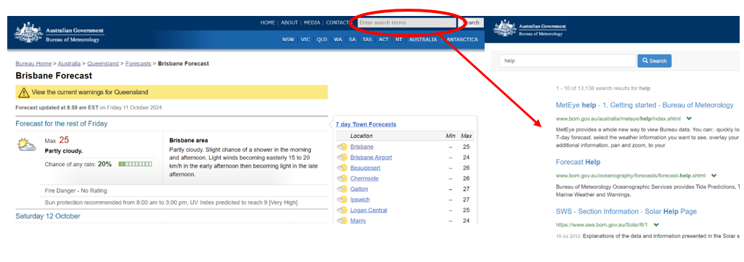

Figure 11: Depiction of 10th Nielsen heuristic violation instance

Despite the BOM having a multitude of assistance and help pages for each data sector, such documentation only becomes apparent when searched for using the query box. The figure 11 instance demonstrates the lapse in clear forecast help documentation on the page in which it is found. However, it evidently exists when searched for. This falls in direct violation of the Nielsen’s 10th heuristic such that although the information is present, it is not easy to find when potentially needed. Although a violation, the instance was given a severity rating of 1, such that the previously mentioned violations are of higher importance as a result of the information still being a simple search away. A proposed solution was the implementation of hyperlinks within the functionality which direct the user to relevant help documentation.

# 3.0 User Based Evaluation

## 3.1 Background

The system usability scale was first detailed by John Brooke in 1986 (Mads Soegaard, 2023). The test employs a standardised 10 part questionnaire to allocate a score between 0 and 100 to a given user interface. Due to the test being extremely cheap, quick and applicable to many interface genres, the SUS test quickly became an established and commonly referenced industry standard. The 10 questions are answered with a score of 1 through 5 depicting the extent to which you agree with the question as shown in figure 12. These results are then converted into a final score by summing the converted scores and multiplying by two and a half. The converted scores themselves are found by subtracting one from each odd question answer, and five minus the even question scores. The SUS score itself can further be evaluated in a number of ways. Commonly, the SUS score is translated into percentile rankings, adjectives, letter grades or acceptable/unacceptable. However, although successful in quantitatively measuring the usability of a given system, the SUS test has no way of describing where or why these usability limitations occur.

As such, it was decided that along side the SUS test, a think aloud test would be conducted to diagnose any usability errors within the system. As described by the inventor, Jakob Nielsen, the think aloud test consists of users verbalising their thoughts whilst they are asked to navigate a UI (Jakob Nielsen, 2012). The test encourages meaningful dialogue throughout the process in order to identify and further clarify errors that have been encountered. Although small sample spaces of users result in limited information about the relative importance of design faults, the process of identifying any flaws would prove valuable in future developer modifications regardless.

Figure 12: Standardised SUS test questions (Bellio, 2024)

## 3.2 Rational

In order for the results of SUS and think aloud tests to be relevant in accessing the strengths and weaknesses of the BOM user interface, governing laws of UI design would be evaluated to translate the test.

It was recognised that the standardised SUS questions largely delt with understanding the complexity and technicality of the user interface. As such, it became apparent that Hick’s law would be extremely relevant in drawing correlations between the SUS score and the complexity of the user interface.

Whilst the SUS test relies mainly on Hick’s law to translate its results, think aloud tests allow for a far more in-depth analysis on particular issues. Specifically, such an analysis will largely rely on Fitts’ law and the 7 UX Design Principles according to Don Norman. The constant verbal feedback and cognition throughout the test highlight which parts of the UI design draw the most attention, require the most thought and perform as expected. Analysis of this feedback against the 7 UX design principles would allow the evaluation of the BOM UI designs constraints, discoverability, feedback, visibility, mapping, consistency and affordance. Additionally, Fitts and Miller laws could be referenced in any user comments made about the accessibility, positioning and usability of featured buttons.

## 3.3 Protocol

In order to collect sufficient and relevant data within the SUS and think aloud tests, it was understood that the same three participants be examined. Participants were individually tasked with:

Locating both the weekly forecast and current radar of Perth, WA, starting from the Bureau of Meteorology home page.

Throughout the task, it was asked that the participants verbalise all thoughts throughout the process in accordance with a think aloud test. Additionally, it was understood the participants would not be conversed with until the task was complete as to not skew the results. The iPhone voice memos app was employed in order to document all comments made by the participants for future reference.

Finally, following the think aloud test, participants were asked the standardised SUS questionnaire. It was intended that conducting the SUS test directly after would insight a honest and relevent SUS score. Further, given the BOM website is a government service with the main purpose of informing users about the current and future forecast, it was decided to convert the SUS score into a percentile rank and corresponding adjective. It was intended that comparing the BOM UI against UIs of varying purposes would insight relevant information into the comparative usability that most users are accustomed to.

## 3.4 Collection of Data

As previously discussed, the results of the think aloud test were recorded, with transcripts provided in appendix one through 3. Raw data from the SUS test were compiled and appropriately process into table 3.

Table 3: Conversion of Raw results to SUS score

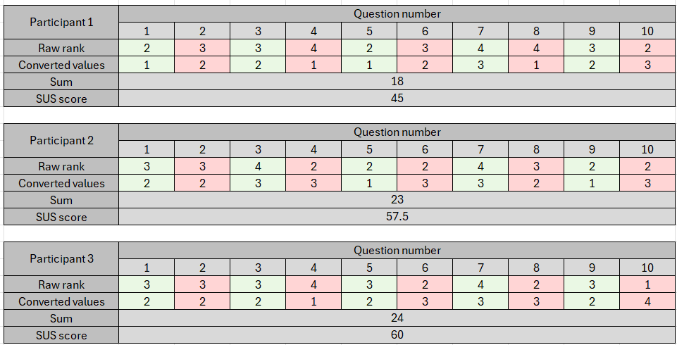

Taking the SUS scores for each of the participants, we find that over the sample space, the BOM UI had an average system usability scale score of 54.1. As previously justified, this score is most useful to the BOM website specifically in adjective and percentile ranking form. This percentile rank was converted and visualised in figure 13 with the adjective for the corresponding SUS score evaluated in figure 14.

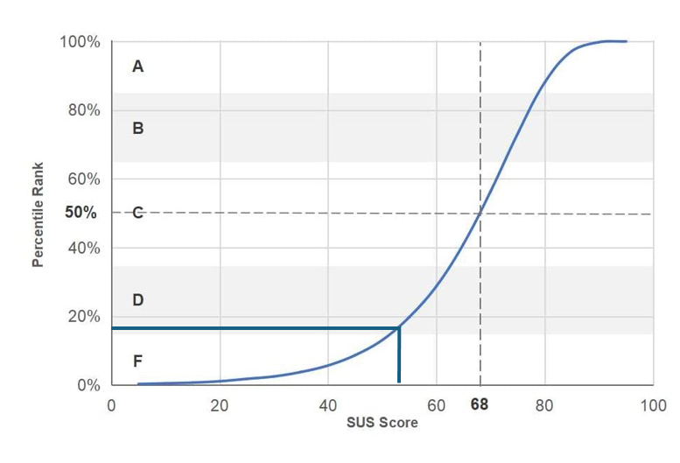

Figure 13: SUS score vs Percentile Rank (Sauro, 2018)

Figure 14: SUS score to adjective conversion table (Sauro, 2018)

## 3.5 Analysis of Data

As is evident in the collated data, the SUS score itself indicates that the BOM interface usability only outranks 18% of all interfaces in the database. The severity of this rank is put into perspective when evaluating the associated adjective, such that the rank indicates the UI is ‘OK’ but borderline ‘Poor’. As discussed in the rational, the poor score is extremely evident of the BOM UI complexity and technicality exceeding the capabilities of the general userbase. This conclusion directly corresponds to Hick’s law such that the system UI is in excess or congested with features, the overwhelmingness of which previously identified in the expert evaluation.

In order to evaluate the particular complexity issues illustrated by the SUS test, the think aloud test results were analysed. It became particularly apparent that the UI featured an extremely congested sequence of buttons when participant one exclaimed their confusion when returning from the radar page saying, “it showed me the same page twice”. In fact, they had not returned to where they were, but rather a similar looking page with a congested series of buttons as identified in figure 10. The similar colour pallet along with no clear identifying symbols other than the directory tab make it excusable as to why this issue was encountered, directly violating visibility within the UX design principles. Participants two and three found it similarly confusing with the large congested series of buttons indicating that they would find “drop downs for each heading” far more efficient.

Whilst from the home page all three participants clicked on the map to investigate the western Australia state page, indicating effective use of the discoverability principle, participants one and two remained confused as to why there where three alternate state selection buttons just as identified in the expert evaluation. This was directly outlined when participant 1 stated that “they list all of the states quite a lot”. This directly violates Fitts’ law, such that the excess of similar looking options resulted in a longer user decision time. Despite the complexity and seeming repetitiveness of the UI, the BOM was extremely successful in satisfying Miller’s law, never demanding that the user commit more that 5 things to memory at a given instance.

# 4.0 Conclusion

The interface inquiry performed on the Australian Bureau of Meteorology website employed expert and user evaluations to quantitatively and qualitatively express the usability of the BOM UI. Utilising Nielsen’s 10 heuristics, the expert evaluation outlined five instances within which in which the system complied. It was found that the system was extremely successful in reporting to the user with system status notifications and appropriate error messages. Additionally, the system demonstrated a match with the real world, utilising maps of Australia to prompt state selection, whilst also promoting recognition over recall. The system effectively accommodated for novice and experienced users, a clear example of which being the detailed MetEye forecast analyser.

Despite these strengths, the system fails to provide users with ease of access to undo/redo functionality and help documentation, failing two heuristics with severity two and one respectively. Further, such violations divert from the typical simplistic user mental models built among other interfaces. Similarly, with a severity ratings of two, and in direct violation of the fourth and eighth heuristics respectively, the system features repeated and an extremely congested view of functionality, many of which irrelevant for novice users. Finally, the system failed to catch a fake email attempts, directly violating the fifth heuristic with severity rating of 3.

System usability scale and think aloud tests were conducted on three participants in order to evaluate how the system UI performed against other systems from a user perspective as well to highlight the relative importance of violations outlined in the expert evaluation. Averaging the three SUS tests, it was found that the system only outperformed 18% of all interfaces in the SUS database with a score of 54.1, which when translated into adjective form is “OK” bordering “Poor”. The think aloud tests indicated that the congested functionality buttons in addition to the button double ups on the home page were of prevalence to novice users, supporting the findings in the expert inquiry. It is therefore suggested development resources are primarily focused into the construction of smaller subheading drop downs along with simplification of the UI in general.

Additionally, the inquiry outlines that the addition of undo/redo buttons, the implementation of help documentation hyperlinks for given functionality and email validity checkers would all prove effective in benefiting the usability of the Australian Bureau of Meteorology website interface for both the novice and experienced user experience.

# References

Bellio, J. (2024, August 23). *System usability scale (SUS) practical guide for 2024*. Articles on everything UX: Research, Testing & Design. <https://blog.uxtweak.com/system-usability-scale/>

BOM. (n.d.). *About us*. Australia's official weather forecasts & weather radar - Bureau of Meteorology. <https://www.bom.gov.au/inside/index.shtml?ref=hdr>

Harley, A. (2018, February 25). *UX expert reviews*. Nielsen Norman Group. <https://www.nngroup.com/articles/ux-expert-reviews/>

Jakob Nielsen. (2012, January 15). *Thinking aloud: The #1 usability tool*. Nielsen Norman Group. <https://www.nngroup.com/articles/thinking-aloud-the-1-usability-tool/>

Mads Soegaard. (2023, November 17). *System usability scale for data-driven UX*. The Interaction Design Foundation. <https://www.interaction-design.org/literature/article/system-usability-scale>

Nielsen, J. (1994, April 24). *10 usability heuristics for user interface design*. Nielsen situationNorman Group. <https://www.nngroup.com/articles/ten-usability-heuristics/>

Nielsen, J. (1994). *Severity ratings for usability problems: Article by jakob nielsen*. Nielsen Norman Group. <https://www.nngroup.com/articles/how-to-rate-the-severity-of-usability-problems/>

Robert Pastel. (2017). *Expert evaluation | CS4760 & CS5760: Human-computer interactions & usability*. CS4760 & CS5760: User Interfaces & Human-Computer Interactions. <https://cs4760.csl.mtu.edu/2017/lectures/expert-evaluation/>

Sauro, J. (2018, September 19). *5 ways to interpret a SUS score*. MeasuringU – UX Research and Software. <https://measuringu.com/interpret-sus-score/>

# Appendix

### Appendix 1

Participant 1 interview (Transcript made with Word Dictate)

“OK so the first thing I'm looking at is the temperature I'm seeing a big warnings current situation going on at the top they list all of the states quite a lot I'm gonna I can see a map of Australia and I can click on WA here so I'm just gonna go into that forecasts 7 day say this is in the forecast for the week you have to Scroll down which is Oh well and then now I need to find the the right the radar and so I can use the back buttons at the top so go back to forecasts Anne know not far enough back to WA and then I'm gonna go onto the Perth radar and have a look in there nothing's happening”.

### Appendix 2

Participant 2 interview (Transcript made with Word Dictate)

“Alright basically I'm not a ref and I know Perth is in WA so I'm gonna click on that and now I see purple colours that's great and then click on that forecast for the rest of the week show me Wednesday Thursday Friday Saturday Sunday Monday Tuesday, nice, pretty all that information, could look a little bit nicer but gets the point across I guess, now I'm gonna go back to full costs oh but this isn’t where I wanted to be, it showed me the same page twice, this looks like the exact same thing, anyway I found the right off looks good I can't see person here as”.

### Appendix 3

Participant 3 interview (Transcript made with Word Dictate)

“Ok I know I have to navigate to Queensland I can see a big map of Australia so I'm gonna click on QLD weirdly though there are some other Queensland options and I really know what they do its bit confusing and then I see radar images so I'll go there OK perfect I found the radar and now I'm really I'm back this is not where I wanted to get back to you OK I'll just go back to all of Australia and then click on the state again, I wish there were drop downs for each heading, in the top left is forecast so I'm clicking on that and there is the forecast”